

**CSL Online Shop Requirements**

# Summary:

# **Virtual Product & Special Delivery Handling (Version3: Code import in Club)**

# JIRA Case#:

[RUBYDT-19674](https://jira.bpuit.pccw.com:8443/browse/RUBYDT-19674)

Acceptance Criteria

* There are two types of Virtual Product: 1) Normal Virtual Product & 2) Special Delivery Virtual Product
* Business user can setup virtual products with redemption code/promo URL collected from merchant
* Customer can check out virtual products with non-delivery flow
* Customer can receive e-redemption email when virtual products order confirmed
* Customer can raise virtual product refund request

Requirements

* Confirmed UI wording: [Virtual Product SFCC_UI wording.pptx](https://pccw0.sharepoint.com/:p:/r/sites/CustomerSelfService/Shared%20Documents/e-Commerce/JIRA-Requirements/RUBYDT-19674%20Virtual%20Product%20handling/Virtual%20Product%20SFCC_UI%20wording.pptx?d=w0f1368d6ca444f529798f1dd7a87e2dd&csf=1&web=1&e=YhKedE)

|  |
| --- |
| **Product Setup & Redemption Code import in Club-Magneto (Club OOTB feature)**   1. Create Virtual Product through Magneto with virtual product setting 2. Redeem code import    1. Normal Virtual Product: Upload the batch of unique redeem code for the SKU       1. User usually have the batch of unique promo code in advance from the 3rd party       2. The number of redemption code upload for SKU equal to stock level       3. 1 SKU( each qty) provides 1 redeem code only (Can’t assign two redeem code for 1 SKU)    2. Special Delivery Virtual Product: No redeem code require to import (non e-voucher) 3. Users need to set up product in club for all special product and inventory in club should be same as SFCC. (no matter merchant = club or not) **[updated on 12 July 2024]** |

**Product Setup in SFCC**

1. User sync Virtual Product from Magneto by existing Product Sync Job
2. There is a new product attribute in Product- **Product Type:** **Physical / Virtual / Special /None** (Updated on 26 July, 2024)

**(Updated on 26 Apr 2024)**

* 1. Product Type’s Mouse over message:

- Physical: Normal product e.g. Mobile phone

- Virtual: e.g. product license key

- Special: bulky product e.g. TV

- (Updated on 26 July, 2024) None: equal to physical (if product sync from club cannot map with SFCC product type, sync job should set it to “none”)

1. System defines the **Product Type** = **Virtual** (“**type_id**”=”virtual”) through Club product sync API ~~and Product Type = Physical for non-virtual product~~ (Updated on 29 July, 2024)
2. System defines the Product Type = None for other undefined type_id through Club product sync API, including simple/configurable (Updated on 29 July, 2024)
3. User requires to update **Product Type** from **Virtual** to **Special** for Delivery by Appointment or Merchant Delivery products
4. User can update Product Type from None to Physical product, both product types are required to be retrieved dimension in O2O delivery method under Checkout process (Updated on 29 July, 2024)
5. User configures **Product Type:**
   1. **Product Type=Virtual**
      1. User selects **Redemption Type: Code/QR code/ Barcode /Promo URL**
      2. Redemption letter shows Redemption Type according to the choice of user
      3. Later phase: As Club only can configure 1 redeem code, user will use “|” to separate 2 redeem code and combine as one, SFCC should break down as 2 redeem codes for display when SFCC receives the redeem code
      4. Add new attributes:
         1. Redemption Period (Free text input by user)
   2. **Product Type=Special**
      1. Add new attributes:
         1. Merchant: display as Merchant id + Merchant Code (Merchant master list is configurable by user)

(Phase 2 Aug 2024): Refer to [eComm-Requirement_Special Delivery Management (Shipment+Merchant).docx](https://pccw0.sharepoint.com/:w:/s/CustomerSelfService/EZYr9j8uS61EsmkV2UlraZ4BBtmwAd39RV_gTlOJhp0wpw?e=4q65li)

* + - 1. Special Type : Delivery by Appointment/ Merchant Delivery ~~(Default “empty”)~~
         1. Special Type’s Mouse over message:

- Delivery by Appointment: Bulky product deliver by our own logistic company

- Merchant Delivery: Direct deliver by vendor

* + - * 1. (Updated on 12 June, 2024) For both Merchant direct and Delivery by appointment, the user should set up the Special Type and Merchant because it affects the shipment breakdown logic.

(The system didn't have validation for missing fields.)

1. User setup [**mega_checkbox_terms**] and [**mega_checkbox_agreement**] for Virtual product T&C
2. User setup **REE** & **PIS** for special product
3. User setup Redemption Details in **Description** section for PDP display and redemption letter
4. Virtual products should not have physical size in SFCC, should skip the checking in checkout page
5. Keep existing Product master and Child SKU attribute overwrite logic

|  |  |
| --- | --- |
| **Product Type:** | Physical / Virtual / Special |
| **Redemption Type:** | Code / QR code / Barcode / Promo URL |
| **Special Type:** | Merchant Delivery / Delivery by appointment |
| ***[Storefront UI Display]*** | Merchant Delivery / Delivery by appointment |

**Product Detail Page**

1. **Virtual Product** 
   1. Show Description (Redemption Detail), Redemption Period & Virtual Product T&C
   2. Allow select Quantity
   3. Allow add to Wishlist
   4. Click [Add to Cart] to add item(s) to cart
2. **Special Product** 
   1. Show Description (Delivery by Appointment/ Merchant Delivery Detail), Product T&C & REE options
   2. Allow select Quantity
   3. Allow add to Wishlist
   4. Click [Add to Cart] to add item(s) to cart

Remarks: User may add E-redemption/Merchant Direct/Delivery by Appointment tag on image to identify the delivery method

|  |  |
| --- | --- |
| PDP - Virtual Product |  |
|  |  |
| PDP – Special – Delivery by Appointment Product | PDP – Special – Merchant Delivery Product |
|  |  |

**Shopping Cart**

1. Allow to include Physical products, Virtual products, and Special products in the same shopping cart.
2. For **Virtual Product**
   1. Show Delivery Tag **“E-redemption”** (show before other tags, e.g. Combo Offer)
   2. Add static redemption description below virtual product name
3. For **Special Product**
   1. Show Delivery Tag “Delivery by Appointment” or “Merchant Delivery”

(show before other tags, e.g. Combo Offer)

* 1. Add static Merchant Delivery / Delivery by Appointment description below product name

|  |
| --- |
| **Shopping Cart** |
|  |

**Checkout Page**

1. **Virtual Products**
   1. Shipping fee calculation should exclude virtual products
      1. User requires to exclude Virtual Products’ categories or SKU in Shipping fee module (OOTB feature)
   2. Add redemption tag & description below virtual product name
   3. If the shopping cart contains only Normal Virtual product
      1. Hide Delivery Method (Delivery & Shop Pickup)/ Delivery Address/ Billing Address
   4. When payment is made successfully
      1. Order is created and passed to Club
      2. Club will pass a redemption code /promo URL through existing Order Query API
      3. Later phase: As Club only can configure 1 redeem code, user will use “|” to separate 2 redeem code and combine as one, SFCC should break down as 2 redeem codes for display when SFCC receives the redeem code

Remarks: Fulfilment report can be retrieved in Magneto

* 1. When payment in progress or payment failed (Updated on 24 May, 2024)
     1. Requires to hidden redemption letter link until payment success

1. **Special Product**
   1. Shipping fee calculation may exclude Special Type products
      1. User requires to exclude Special Type categories or SKU in Shipping fee module (OOTB feature)

(Phase 2 Aug 2024)(Updated on 25 June, 2024)

* + 1. Users have the option to set special products with or without a special product shipping fee.

If a special product has a shipping fee, it is calculated based on the quantity. For example, 1 Samsung TV would have a $100 shipment fee, while 2 Samsung TVs would have a $200 shipment fee. (OOTB feature)

If the shipping fee is set at the product level, it is suggested to group them in categories.

* 1. Add delivery tag & description below product name
  2. Allow customers to add more than 1 Special Type Product (of different SKU)
  3. If the shopping cart contains any Special Type product
     1. Hide Shop Pickup from Delivery Method
     2. Delivery Time section is not required
  4. Phase 2: Design a separate district list for special products in backend. The district list may differ from the normal Club delivery if the customer only purchases special products.
     1. Excluded districts of special products are the same as ~~normal home delivery~~ Standard Delivery products.
  5. (Phase 2 Aug 2024) (Updated on 12 June, 2024) Before payment (redirect to OPP), the system checks if any special product is missing a Special Type/Merchant.
     1. If so, prompts error to disallow customer to proceed with checkout.

1. **Shipping Fee Summary** (Phase 2 Aug 2024)
   1. In summary section, break down shipping fee by delivery type
      1. For Merchant Delivery, break down by merchant name
   2. Add a tool tip next to section name “Shipping”
2. **Shopping Cart Summary** (Phase 2 Aug 2024)
   1. Separate to delivery batches by delivery type & merchant
      1. For e-redemption, batch name = ”E-redemption”
      2. For others, section name = ”Batch# - {deliveryType) - {merchantName}”
   2. Show description text for each batch. The text should be configurable by delivery type.
   3. (Updated on 31 July, 2024) If there is only 1 batch delivery, skip batch display section
   4. ~~Listing sequence:~~   
      ~~E-redemption > Shop pick up > Home Delivery > Delivery by Appointment > Merchant Delivery~~
   5. (Updated on 2 Aug, 2024) (Phase 2 Aug 2024) Retrieve product dimensions for O2O shipment method via club API.
3. Products should retrieve dimensions for the following product types: None/Physical.
4. Products should not retrieve dimensions for the following product types: Virtual/Special Product.
5. For orders that include both product types that require dimension retrieval and those that do not, the order should be passed to Club to retrieve dimensions.

|  |  |  |
| --- | --- | --- |
| **Checkout** - Virtual Product ONLY | **Checkout** – Virtual + Special + Physical (3 types) | **Prompt error if product setup is incomplete** |
|  |  | *Product abnormal and cannot be placed. Please contact CS.* |

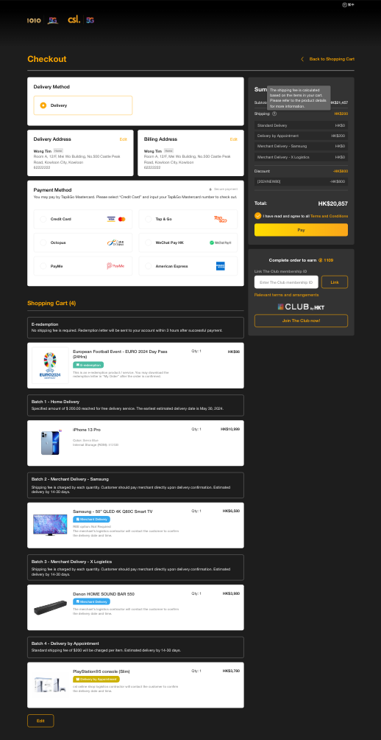

**Order Detail Page**

1. **Virtual Product**
   1. When LDA passed redeem code to SFCC, the order status update to “Order Completed”
      1. If the order contains both virtual & physical products, mark “Order Completed” when all items delivery completed
      2. If the order contains virtual product only, mark “Order Completed” when the virtual product’s redemption email delivery completed
   2. Show the link to download e-redemption letter below product name
      1. For payment success virtual product order, both order confirmation email and ODP should show redemption letter link even the letter is still generating (Updated on 24 May, 2024)
      2. If same SKU qty>1, the downloaded file should include all redemption details in separated pages
      3. If the order contains different SKUs, the download link should appear under each of the SKU ([view sample redemption letter with multiple codes](https://pccw0.sharepoint.com/:w:/r/sites/CustomerSelfService/Shared%20Documents/e-Commerce/User%20Materials/Email%20and%20SMS%20Template/version2/16_Virtual%20product%20redemption%20example.docx?d=w4b07aed2435948daa9f5ac73f9b1701d&csf=1&web=1&e=mTpZje))
      4. E-redemption file should be the same language as user selected in locale.
   3. In Order Information section
      1. Show "-" for Delivery address/ Billing Address/ Delivery Method
      2. Show "E-redemption" for Delivery Method
   4. [Return] button should be available within 14 days after the *Order Completed Date*
   5. Display product’s T&C section: [**mega_checkbox_terms**] (Apply to all types of products including Physical Product)
2. **Special Product**
   1. Club deducts stock once order placed
      1. The order won’t auto-trigger “Order Completed” by system
      2. Delivery status will be updated by user by batch import
      3. No e-redemption letter is required to generate
   2. In Order Information section
      1. Show "Delivery" for Delivery Method
   3. [Return] button should be available within 14 days after the Order Completed Date
   4. Display product’s T&C section: [**mega_checkbox_terms**] (Apply to all types of products including Physical Product)
   5. Display Product Information Sheet
   6. ~~For Merchant Special Delivery type, (Phase 2 Aug 2024) Updated on 5 July~~
3. ~~Show Merchant Name (e.g. Merchant Delivery: Samsung)~~
4. ~~Show Appointment Method: Contact Number/ Email (use “/” to separate if more than one contact info) (Updated on 2 July, 2024)~~
5. ~~Show Appointment Detail~~
6. ~~Show DOA Policy~~
7. ~~Show Invoice Remark (refer to invoice)~~
8. ODP Order Progress Display (for Phase 1 ONLY)
   1. Follow order status returned in order level
      1. Order status=”Open” >> ODP progress: “Order Created”
      2. Order status=”Completed” >> ODP progress: “Delivery Completed”
      3. e.g. Special Type product shipment status= “Open” & Physical product shipment status= “Completed” >> ODP progress: “Order Created”   
         (Since the order is not mark Completed yet)
      4. When only virtual product has purchased, get "Order Created Date" as Completed Date (Updated on 14 May, 2024)
9. Delivery Status Display (Phase 2 Aug 2024)
   1. Remove delivery progress bar on top
   2. Include 2 new columns “Delivery” and “Status”
      1. “Delivery” shows the delivery type of specific item
      2. “Status” shows the delivery status of specific item
         1. For Special product type, show the delivery status on item level.
         2. For ~~Home Delivery~~ Standard Delivery / Shop Pickup/ Virtual product type, show the delivery status on shipment level.
   3. Show SKU below each item
   4. Show Delivery Date below each item (YYYY-MM-DD)
      1. Show “-” if not delivered yet.
   5. ~~Order Details Listing sequence:~~ 
      1. ~~E-redemption > Shop pick up > Home Delivery > Delivery by Appointment > Merchant Delivery~~
10. Frontend Delivery Status (Phase 2 Aug 2024) Updated on 2 July, 2024)
    1. Physical Product  
       SFCC groups all physical products (Product Type=Physical) together in one shipment and passes it to Club.

Club will then return the delivery status of the shipment.

SFCC will display the eCommerce delivery status of each individual product.

|  |  |  |  |  |  |  |
| --- | --- | --- | --- | --- | --- | --- |
| **Physical product** | **eComm: Delivery Status show in ODP by Product (Frontend)** | **The Club: Delivery Status**  **(All products combined to 1 Shipment)** | **Description** | **SFCC: Shipping Status (Backend)** | **System Trigger Event** | **Remarks** |
|  |
| Order placed / 訂單已建立 |  |  | not shipped | SFCC order created and linked with customer account | Payment in progress/Payment failed |  |
| Order confirmed/訂單已確認 | Order confirmed | Club received fulfillment order | SFCC sent out Order Confirmation Email | New Status from LDA, in development |  |
| Order processing / 訂單準備中 | Ready To Ship | Club prepared parcel | NA |  |  |
| Ready to ship / 準備發貨 | In Transit | Shipment in transit to customer | shipped | NA |  |  |
| Ready for Pick-up / 可於自取點取貨 | In Store | Parcel arrives in store | SFCC sent out Electronic Redemption email |  |  |
| Ready for Pick-up (1-day arrived) / 可於自取點取貨(已到達一天) | Reminder24 | Parcel arrived in store over 24 hours | NA |  |  |
| Ready for Pick-up (2-day arrived) / 可於自取點取貨(已到達兩天) | Reminder48 | Parcel arrived in store over 48 hours | SFCC sent out 48 hours reminder email |  |  |
| Pick-up period past / 已過領取限期 | Expired72 | Parcel arrived in store over 72 hours | NA |  |  |
| Stock(s) returned to warehouse / 貨品已回倉 | Return To Hub | Shipment has been returned to Warehouse | NA |  |  |
| Order cancelled / 訂單已取消 | Cancelled | Shipment has been cancelled/refunded | NA |  |  |
| Order completed / 訂單已完成 | Delivered | Shipment has been delivered or parcel has been collected by the customer | SFCC sent out Order complete email |  |  |

* 1. Virtual Product  
     SFCC groups all virtual products(Product Type=virtual) together in one shipment and passes it to Club.

Club will then return the delivery status of the shipment.

SFCC will display the eCommerce delivery status of each individual product.

|  |  |  |  |
| --- | --- | --- | --- |
| **Virtual Product** | **eComm: Delivery Status show in ODP by Product (Frontend)** | **SFCC: Shipping Status by batch (Backend)** | Remarks |
|
| Order placed / 訂單已建立 | not shipped |  |
| E-redemption letter issued / 電子換領信已發出 | shipped |  |

* 1. Special Product (Per merchant)  
     SFCC breaks down shipments of Special Products (Product Type=Special) based on the following criteria:

1. Product Type=Special

2. Merchant (For detailed logic, please refer to "Backend: Order Module-3.Special Product")

Once the user manually updates the delivery status at the SKU level, SFCC will display the eCommerce delivery status of that SKU as "Delivery Completed".

|  |  |  |  |  |
| --- | --- | --- | --- | --- |
| **Special Product** **(Per merchant)** | **eComm: Delivery Status show in ODP by Product (Frontend)** | **Status Update by Product (Import Report)** | **SFCC: Shipping Status by batch (Backend)** | Remarks |
|
| Order placed / 訂單已建立 | not shipped | not shipped |  |
| Order completed / 訂單已完成 | shipped | shipped |  |

1. ~~Delivery Fee Summary (Phase 2 Aug 2024)~~
   1. ~~Break down delivery fee of charged delivery type (e.g. [Delivery by Appointment] )~~

|  |  |  |
| --- | --- | --- |
| **ODP** - Virtual Product ONLY | **ODP** – All types | **(Phase 2)** ODP – Delivery status |
|  |  |  |

**Order confirmation email/ e-Redemption Letter/ Invoice**

* Order Confirmation email template: [1_訂單確認 fin_20240418](https://pccw0.sharepoint.com/:w:/r/sites/CustomerSelfService/Shared%20Documents/e-Commerce/User%20Materials/Email%20and%20SMS%20Template/version2/1_%E8%A8%82%E5%96%AE%E7%A2%BA%E8%AA%8D%20fin_20240418.docx?d=w073b9d6f0a4e494794e57ef5a23392dd&csf=1&web=1&e=8oPedN)
* E-redemption letter template: [16_Virtual product redemption template.docx](https://pccw0.sharepoint.com/:w:/s/CustomerSelfService/EcHk15TcTeZLnI4lPOsIUAEBUtq2OJxLBOvQrq0_l9FSPQ?e=xLfj1v)
* Invoice: [7.1_收據_20240315.docx](https://pccw0.sharepoint.com/:w:/r/sites/CustomerSelfService/Shared%20Documents/e-Commerce/User%20Materials/Email%20and%20SMS%20Template/version2/7.1_%E6%94%B6%E6%93%9A_20240315.docx?d=wd72146a55c2e4d5fbbf7b68b6bce219e&csf=1&web=1&e=xOUtXV)

1. **Order confirmation email** 
   1. Should send for all types of product purchase
   2. Should include below attributes per product (apply to all product types)
      1. <<Product name>>
      2. Quantity: <<Quantity>>
      3. Product Information Sheet: <<link>> (if applicable)
      4. REE: <<Option>> (if applicable)
      5. ~~(Phase 2 Aug 2024) [<<Delivery Type >> - <<Merchant Name>>] (e.g. [Home Delivery], [Merchant Delivery – Samsung])~~  
         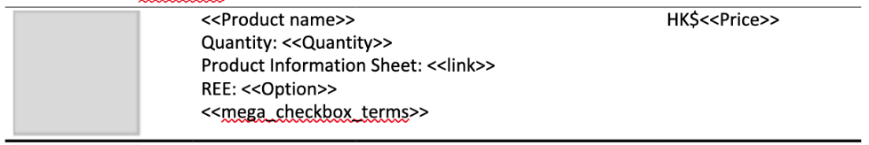
      6. <<mega_checkbox_terms>> (if applicable)
   3. Add redemption description in the email opening with hyperlink.
      1. Click to redirect to “My Orders” page  
         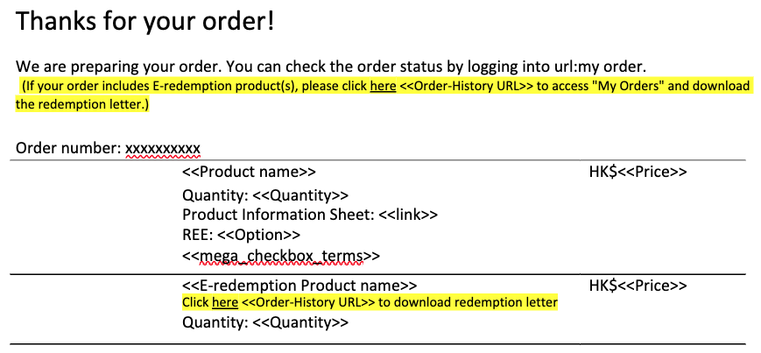
   4. Add hyperlink below each E-redemption product.
      1. Click to redirect to “My Orders” page and display the print dialog of the corresponding product.  
          
   5. (Phase 2 Aug 2024) ~~Delivery Fee Summary~~
      1. ~~Shows delivery fee breakdown by delivery types (e.g. Delivery by Appointment) (Updated on 5 July)~~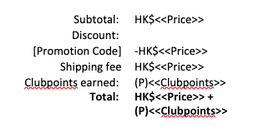
2. **E-redemption letter**
   1. E-redemption letter link will be attached in the Order confirmation email**.** Customer can follow the link to access "My Orders" and download the redemption letter.
   2. (Phase 2) The customer is allowed to download both the English and Chinese versions of the redemption letter, depending on the language they have selected.
3. **Invoice**
   1. (Phase 2 Aug 2024) Should include below attributes per product (apply to all product types). According to language selected.
      1. <<Product name>>
      2. <<IMEI>>
      3. <<Attributes>>
      4. <<REE>>
      5. ~~[<<Delivery Type >> - <<Merchant Name>>] (e.g. [Home Delivery], [Merchant Delivery – Samsung])~~
      6. [<<Delivery Date>>] (show “N/A” if not applicable)
      7. ~~<<Appointment Method>> : <<Contact Number>> / <<Email>> (use “/” to separate if more than one contact info)~~
      8. ~~<<Appointment Detail>>~~
      9. ~~<<DOA Policy>>~~
      10. ~~<<Invoice Remarks>>~~
      11. <<mega_checkbox_terms>> (if applicable)   
            
          Example: [7.1_收據_20240621.docx](https://pccw0.sharepoint.com/:w:/s/CustomerSelfService/ERLV-Sa2yK5OpBrfJE99lVABwSrXeBhiAkfniy87dkvcxA?e=BNJcA3)

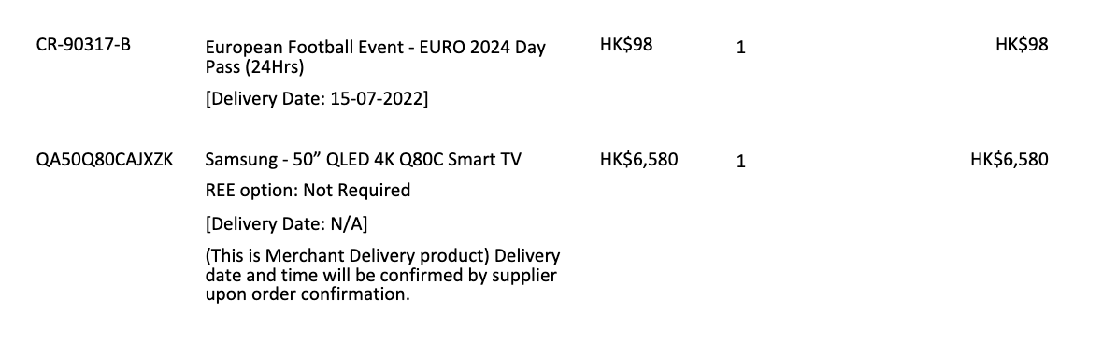

* 1. Below virtual product, show N/A for Delivery Date (Updated on 14 May, 2024)
  2. (Phase 2) The customer is allowed to download both the English and Chinese versions of the invoice, depending on the language they have selected.
  3. (Phase 2 Aug 2024) Delivery Fee Summary
     1. Shows delivery fee breakdown by delivery types (e.g. Delivery by Appointment) (Updated on 5 July)

|  |  |
| --- | --- |
| **Order Confirmation email:** | **E-redemption letter:** |
|  |  |

|  |  |
| --- | --- |
| **Redemption code - QR** | **Redemption code – Bar Code** |
|  |  |
| **Redemption code - Code** | **Redemption code – URL** |
|  |  |
| *\*\* All code formats are for reference only \*\** | |

**Backend: Order Module**

1. **All product types**
   1. Snapshots <<mega_checkbox_terms>> (apply to all product types), display in Order Detail, Invoice & Order Confirmation Email (Updated on 23 May: Currently, system will show and capture Master product’s T&C)
2. **Virtual Product**
   1. Snapshots Description and redeem period in order level
3. **Special Product**
   1. Snapshots attributes require to store in Special Product order, fields below will be included in order XML
      1. customer name : Input in Checkout Page-Shipping address [Last Name][ First Name]
      2. Address : Input in Checkout Page-Shipping address [ADDRESS]
      3. contact number: Input in Checkout Page [MOBILE NUMBER]
      4. removal service or not : Select in PDP REE option
      5. ~~propose removal date: TBC~~
      6. ~~request delivery date : TBC~~
      7. sales memo date : System generates Order Create Date
      8. sales memo number : System generates Order No.
      9. item# AND qty: System displays SKU & qty
      10. ~~product information sheet~~
      11. ~~back iso (for completion order )~~
   2. System will break down shipment package based on the following criteria:

(a) Product Type: Virtual product/Physical Product/Special Product

(b) By Merchant

E.g. A customer buy Virtual product A + B, Physical product C, Special product D from Merchant X and Special product E&F from Merchant Y

* + - Expected Result: Should be separated as 4 shipments with shipment id:
      * Shipment 01: Product A + B
      * Shipment 02: Product C
      * Shipment 03: Product D
      * Shipment 04: Product E&F
  1. **Delivery, Shipment & Order Status** update:
     1. System should update Virtual Product shipment status as Completed once the redeem code is retrieved from Club Query Order API.
     2. ~~User should update Special product’s shipment status manually. Order id, Shipment id and shipment status can be imported by batch.~~
     3. ~~Phase2: User should update each Special product’s delivery status manually (If Merchant not equal to Club). Once all SKUs under same shipment are delivered, system will update Shipment Status automatically.~~
     4. (Updated on 17 June, 2024)

(Phase 2 Aug 2024): Special product shipment handling (TBC):

-Need to handle special product deliver by Club & other logistics.

-(Updated on 12 July, 2024) All special products (Club & other logistics) are required to be passed to the Club in order to create order and deduct stock.

-In the case of Club delivery, the user sets the product type as a normal product and then syncs it to SFCC (configuring the product as delivery by appointment with Merchant=Club).

-The shipment will be updated through the Club-Merchant integration, meaning that if Merchant=Club, the shipment status will be synced by Club instead of being manually updated by the user.

-For other logistics (Merchant isn't Club), shipment status will be updated by user manually.

**TBC:** Will Club separate sending out shipment statuses to SFCC when an order includes both normal products and special delivery products?

For example, if a customer places an order with normal products a+b and delivery by appointment products c+d,

Club will update shipment 1 (products a+b) status and shipment 2 (products c+d) status?

If yes, SFCC should be able to handle multiple shipment statuses and sync them to SFCC.

* + 1. System checks and updates **Order Status** as Completed if all shipments are delivered.

Later phase(Updated on 24 June, 2024):

SFCC has a quota limit on shipment per order (The quota is 20 shipment). As there will be multiple shipments in an order, and number of items could be exceed the number of shipments.

Suggest making an enhancement on limiting the number of items that a customer can add to cart. If the exceed the limit, make a frontend warning to customer (warning message required) and not allow to add more item to the cart.

User can decide the limitation (not more than 20).

Here is the effort:

BO - checking and blocking the number of shipments in cart/checkout page. (2md)

FO - Warning message prompt and any limitation message display. (2md)

Total : 4md

**Backend: Special Delivery Report (New)**

**Phase1:**

User can set a schedule job or manual download Special Delivery Report which contains order’s shipment (Product Type: Special)

(Updated on 29 July, 2024) Remarks: Exclude Order Status= “Created” and “Failed” order in report

File Name: Special Delivery Report [system generation date]

* + 1. Special Delivery Type
    2. Merchant Name
    3. Order no.
    4. Shipment id.
    5. Shipment Status
    6. customer name : Input in Checkout Page-Shipping address [Last Name][ First Name]
    7. Address : Input in Checkout Page-Shipping address [ADDRESS]
    8. contact number: Input in Checkout Page [MOBILE NUMBER]
    9. removal service or not : Select in PDP REE option
    10. ~~propose removal date: TBC~~
    11. ~~request delivery date : TBC~~
    12. sales memo date : System generates Order Create Date
    13. item# AND qty: System displays SKU & qty
    14. ~~sales memo number : System generates Order No.~~
    15. ~~back iso (for completion order )~~

**Phase2 Aug, 2024:**

Only 3 field is mandatory field, including i,ii, xvii. (updated on 8 Aug)

1. Order no.: System exports (this field is mandatory field)
2. Shipment id.: System exports (this field is mandatory field)
3. Shipment Status: System exports. System auto changes to “Shipped” when all SKUs under same shipment are “Delivery Completed”
4. Shipment System Date: When all SKUs’ delivery status under same shipment are shipped, system will capture the actual date of last update
5. Special Delivery Type: System exports. Merchant Delivery/ Delivery by Appointment
6. Merchant Name: System exports
7. customer name: System exports Checkout Page-Shipping address [Last Name][ First Name]
8. Address: System exports Checkout Page-Shipping address [ADDRESS]
9. contact number: System exports Checkout Page [MOBILE NUMBER]
10. removal service or not: System exports PDP REE option that the customer selected
11. sales memo date: System exports Order Create Date
12. SKU: System displays SKU
13. Product name: System displays product name
14. Item code: System displays item code
15. Qty: System displays quantity
16. Delivery Status Update: System exports or user input “Delivery Completed” to update status
17. Delivery Date: System exports or user input Delivery Date to update (date format=DD/MM/YYYY), this is mandatory field if user input Delivery Status (Updated on 5 Aug, 2024)
18. Delivery Note no.: System exports or user input to update (optional)
19. Serial no./IMEI: System exports or user input to update (optional)

Sample: [Special Delivery Report 20240412.xlsx](https://pccw0.sharepoint.com/:x:/r/sites/CustomerSelfService/Shared%20Documents/e-Commerce/JIRA-Requirements/RUBYDT-19674%20Virtual%20Product%20handling/Special%20Delivery%20Report%2020240412.xlsx?d=w507fa9880c904e16ba7e131a46f28192&csf=1&web=1&e=EegwbL)

**Backend: Shipment Update Job**

**Solution1: Create a job in Custom Objects (Phase1)**

-Allow user to input shipment id list into specific field, then run job once to update Shipment Status

Remarks: No history for record import. User may download Special Delivery Report to verify Shipment Status update.

(Phase 2 Aug 2024)**:**

Solution2: Update Shipment Status in Special Delivery Report and import for shipment status update

BE requirement: [eComm-Requirement_Shipment Status Management](https://pccw0.sharepoint.com/:w:/r/sites/CustomerSelfService/Shared%20Documents/e-Commerce/JIRA-Requirements/eComm-Requirement_Shipment%20Status%20Management.docx?d=w3ff62b964b2e44adb26915d9496b699e&csf=1&web=1&e=D4GMZ1)

~~Solution2 - Create BM page (6+2 = 8md+)~~

~~i. Allow user to update order/shipment by using csv file~~

~~ii. Allow shipment id filtering by order/shipment id~~

~~iii. Allow batch execution of shipment status update~~

~~iv. Keep track logging history files~~

~~v. Validate csv file (Report file is csv that contains: Order Id/Shipment Id/Customer Name/...)~~

~~vi. Pending BM template design (2md+)~~

**Backend: GL Report Generation**

Phase 2 Aug 2024: Good delivered will be booked on order complete month by items

1. E.g., Order 1 includes item 1 which delivered on 30 March and item 2 delivered on 2 April. Both item 1 & 2 should include in April GL booking

(Updated on 14 June, 2024)

Remarks: SFCC won’t cater Special product’s shipment fee that excluded in Shipment method

(TBC) Phase 2 Aug: Special products shipping fee booking logic (Updated on 24 June, 2024)

**Backend: REE Report**

1. Existing REE report sent to CS should not include Special Delivery products’ REE records as Merchant will handle REE cases

**Backend: Order Report (HKT Converter)**

1. **Order Creation Report**:
2. Add [Product Type], [Special Type], [Shipment Id]and [Product Shipment Status]
3. [Product Shipment Status]: Replace existing [Shipment Status (by item level)] field with below logic

For Product Type= “Physical”, retrieve Club Shipment Status

For Product Type= “Special”/ “Virtual”, display “Not Shipped” or “Delivered” depended on SFCC shipment status (Updated on 28 May, 2024)

1. **Order Delivery Report** and **Order un-delivery report** ~~should be retrieved as shipment level instead of order level~~
   1. (Phase 2 Aug 2024):
      1. Add new fields [Shipment ID] and [~~Shipment Delivery Date~~ Shipment System Date] (Updated on 5 Aug, 2024)
      2. [Shipment Status (by item level)] already existed in report, should retrieve correct shipment status by item level and update name to [Product Shipment Status]
         * 1. Product Shipment Status: System should compare [Selected Delivery Date] and retrieve the correct shipment status and delivery date under the selected Date picker.

E.g. item A (physical product) shipment status is In Transit on 20 July, 2024, and change to Delivered on 24 July, 2024.

When user selected Date picker=22 July, 2024, then [Product Shipment Status]=In Transit and [~~Shipment Delivery Date~~ Shipment System Date]=empty

1. **RMA Report** (Phase 2 Aug 2024):
   * 1. [Shipment Status (by item level)] already existed in report, should retrieve correct shipment status by item level and update name to [Product Shipment Status]

# Reference:

**Case study:**

|  |  |  |  |  |  |
| --- | --- | --- | --- | --- | --- |
| **Example** | **Foodpanda Pro eVoucher** | **Workshop/ Online course** | **eVoucher** | **~~Retail product 1~~** | **~~Retail product 2~~** |
| Redeem channel | Merchant's App | Merchant's site | Online/ Retail Store | ~~3~~~~rd~~ ~~party/ Retail Store~~ | ~~3~~~~rd~~ ~~party/ Retail Store~~ |
| Redeem type | Code (unique/ generic) | Activation URL  (unique/ generic) | QR code  (unique/ generic) | ~~Slide bar to mark off e-voucher~~ | ~~Scan QR code to mark off e-voucher~~ |
| Stock level | Y | Y | Y | ~~Y~~ | ~~Y~~ |
| Code Source | Pre-upload | Pre-upload (generated by BU) | Pre-upload | ~~Pre-upload~~ | ~~Pre-upload~~ |

**Product Matrix:**

|  |  |  |  |
| --- | --- | --- | --- |
| **Product Type** | **Delivery Handling** | **Shipment Status** | **Order Status** |
| Physical | * ~~Home Delivery~~ Standard Delivery * Shop Pick up | * Update by Club | * Mark “Completed” when all Shipment ID status=Completed |
| Virtual | / | * SFCC updates to Completed once redemption code is retrieved |
| Special (csl Delivery) | * ~~Home Delivery~~ Standard Delivery | * Require manual batch update by **user** |
| Special (Merchant Delivery) | * ~~Home Delivery~~ Standard Delivery | * Require manual batch update by **user** |
| Physical + Virtual | * ~~Home Delivery~~ Standard Delivery * Shop Pick up | * Physical: Update by Club * Virtual: Update by SFCC |
| Physical + Special | * ~~Home Delivery~~ Standard Delivery | * Physical: Update by Club * Merchant: Require manual batch update by **user** |
| Special + Virtual | * ~~Home Delivery~~ Standard Delivery | * Merchant: Require manual batch update by **user** * Virtual: Update by SFCC |
| Physical + Virtual + Special | * ~~Home Delivery~~ Standard Delivery | * Physical: Update by Club * Virtual: Update by SFCC * Merchant: Require manual batch update by **user** |
| Special (csl Delivery) + Special (Merchant Delivery) | * ~~Home Delivery~~ Standard Delivery | * Require manual batch update by **user** |